- As expected, UK CPI inflation rose sharply in October, and in the short-term the clear direction of travel for inflation will be upward. Despite a raft of public appearances by the Bank of England's Monetary Policy Committee this week, there was little indication that the committee is likely to deviate from the current 'cut-hold' tempo of rate cuts.
- Elsewhere, October's retail sales and November's flash S&P Global survey both disappointed, but we think these outturns probably understate the underlying momentum in the economy. Therefore, we still think there's a good chance that quarterly GDP growth will pick up in Q4.
The monetary policy outlook came under the microscope this week, with the release of October's inflation data and a raft of public appearances by members of the Bank of England's Monetary Policy Committee.
As we highlighted last month, inflation was always likely to rise sharply in October given Ofgem's 9.5% hike in the energy price cap would come into play and the strong base effect that supressed core inflation in September would fade. In the event, CPI inflation jumped to 2.3% in October from 1.7% in September, with outturns for all sub-components broadly in line with expectations. The outturn was 0.1ppt higher than the BoE expected, but we doubt the data will have shifted any of the MPC's views.
In the near-term, we continue to think that inflation will rise further. Base effects caused by a series of weak outturns for core goods prices last winter and sticky services inflation should push up core inflation from next month. Meanwhile, this morning's Ofgem price cap announcement revealed that average household energy bills will rise a further 1.2% from January 1. Though base effects will temporarily cause the drag from the energy category to increase again between January and April, that drag should then disappear entirely from the spring, driving headline inflation higher through much of 2025 (Chart 1).
Chart 1: In the near-term we think the clear direction of travel for inflation is upwards
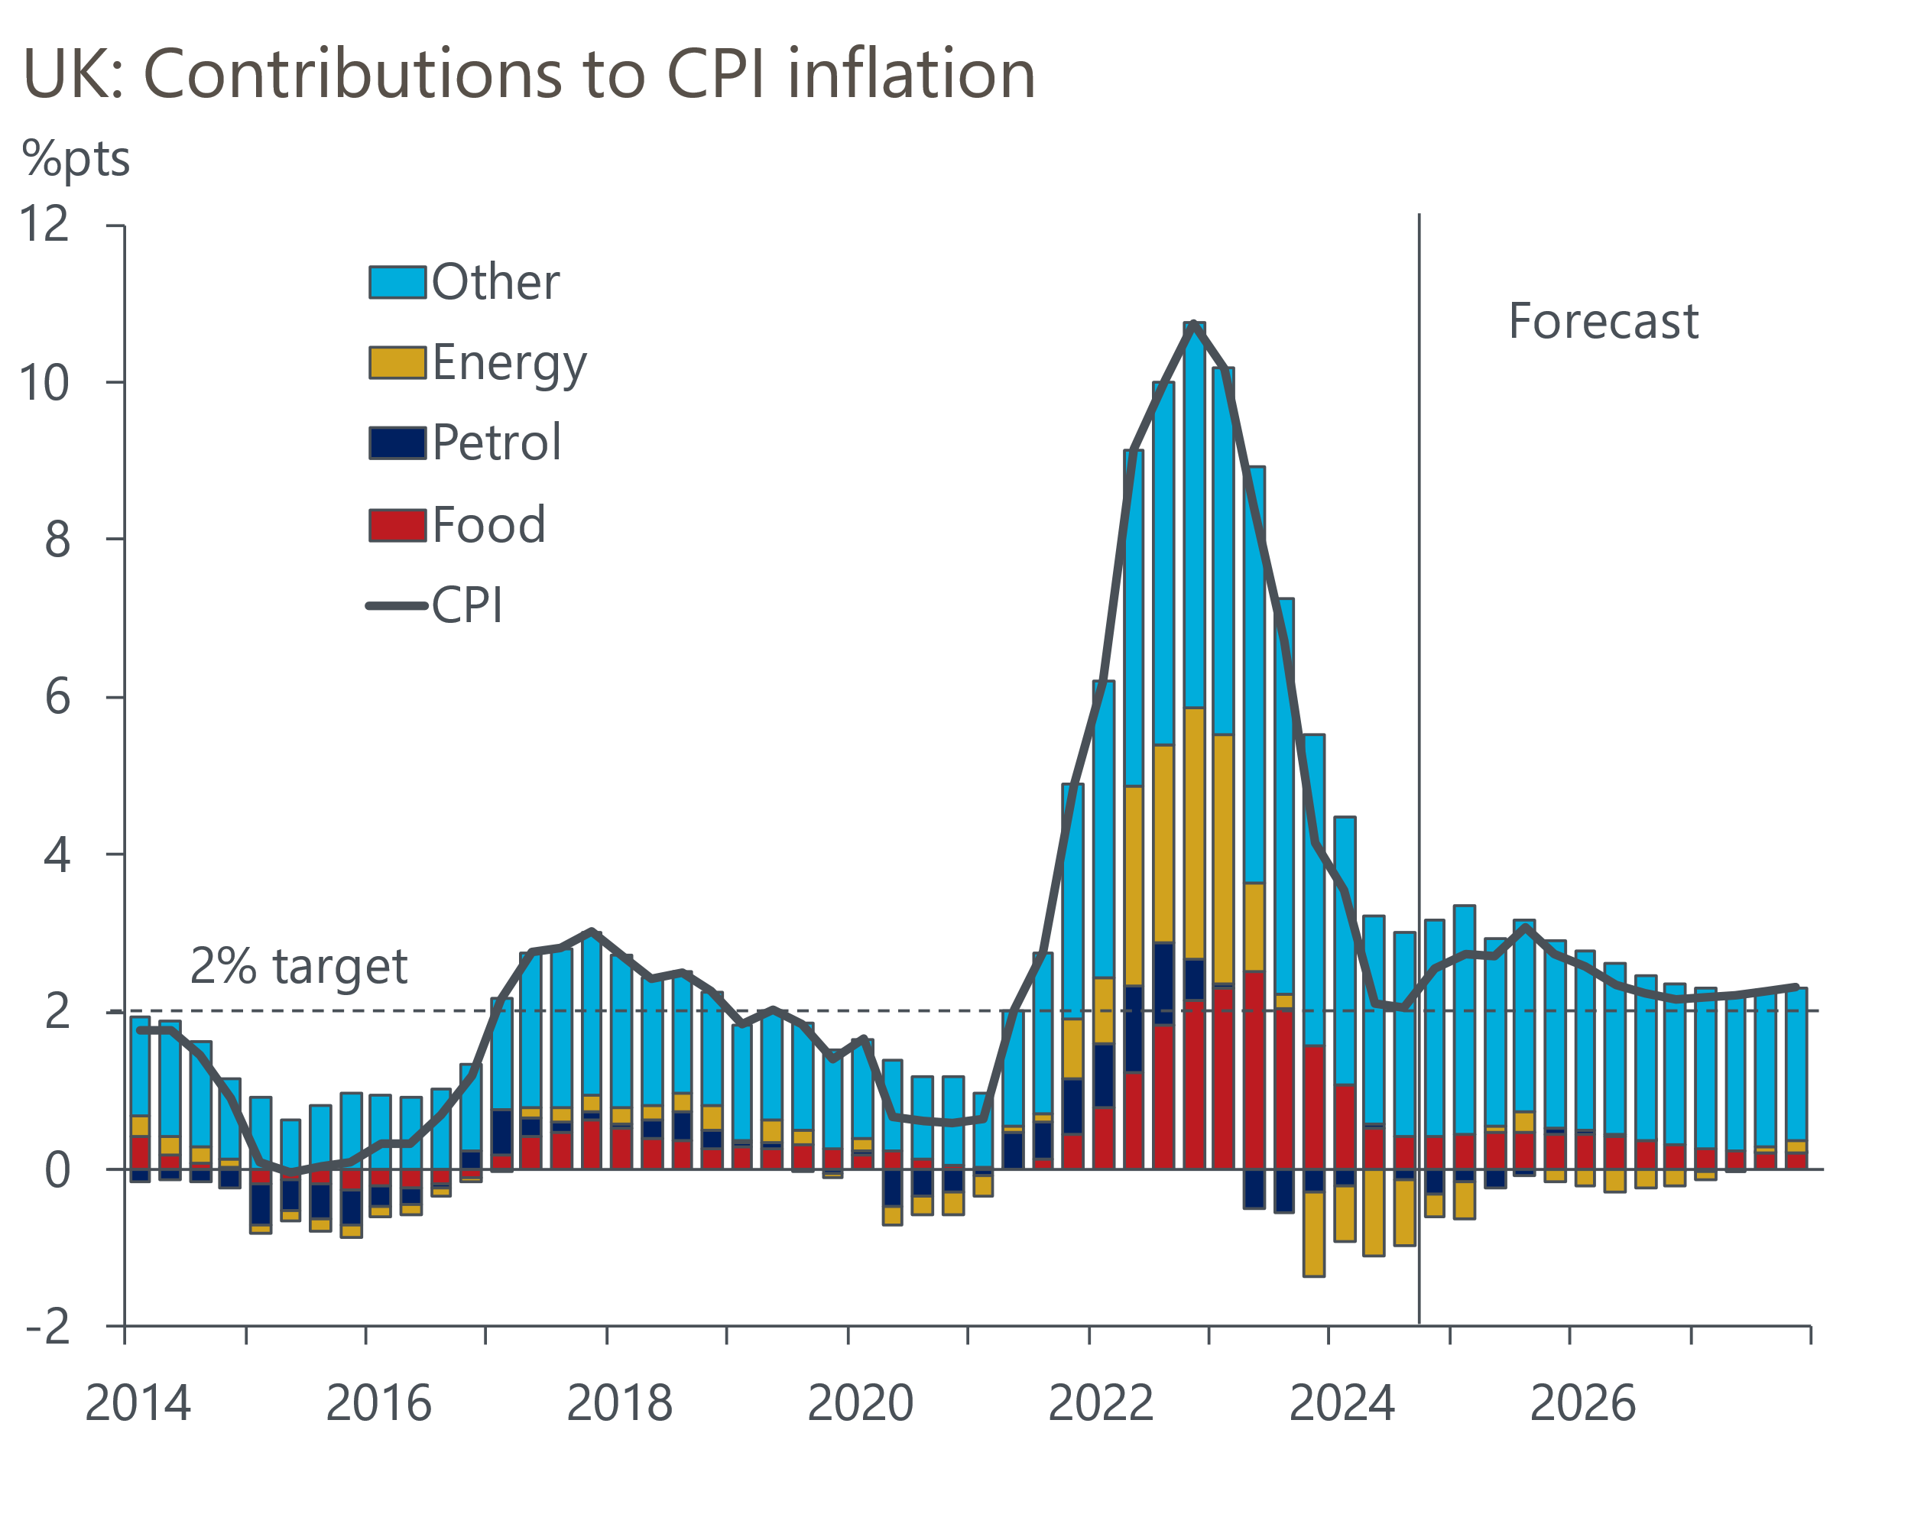
Sources: Oxford Economics, Haver Analytics

Recent events suggest that the pickup in inflation next year is likely to be slightly stronger than we had thought a month ago. We raised our forecast for services inflation in 2025 in response to the Budget – as well as VAT being imposed on private school fees from January, we expect firms to pass on some of the impact of higher employers' national insurance contributions into prices. Meanwhile, we also expect Donald Trump's victory in the US election to result in a stronger dollar, with looser US fiscal policy implying fewer interest rate cuts from the Federal Reserve. Weaker sterling will mean higher prices for imported goods.
The MPC has long touted its collective view that the restrictiveness of monetary policy would be reduced gradually. So far, this has meant one 25bps rate cut each quarter. With six of the nine committee members providing on-the-record comments this week, it was a good opportunity to see whether any would provide hints that they could adopt a slightly more aggressive approach to cutting rates next year.
All MPC members set out their views within the framework of the three scenarios of varying inflation persistence outlined in the minutes of recent meetings. Apart from Catherine Mann, who continued to advocate for the MPC's most hawkish scenario, all continued to align themselves with the MPC's middle scenario. This scenario assumes a period of slack is required for price- and wage-setting to fully normalise and is consistent with the cut-hold tempo continuing. Several members – most notably Deputy Governor Sir Dave Ramsden and Professor Alan Taylor – also placed a relatively high probability on the more dovish scenario, which assumes inflation persistence dissipates without a marked rise in unemployment. But frustratingly, they were not clear on what developments could encourage them to make this scenario their baseline and see them vote for back-to-back cuts.
Given the lack of a meaningful shift in views amongst MPC members, we see little reason to change our call that the MPC will maintain its gradualist approach to loosening policy and deliver 100bps of cuts in 2025.
Similarly, we don't expect the week's poor activity data will cause the BoE to deviate from its 'cut-hold' pattern. Retail sales volumes fell sharply in October, but this followed three successive m/m gains. Furthermore, the sectoral breakdown suggested that the decline was driven in large part by a decline in non-food sales, a sector we flagged last week as looking ripe for a correction after a recent period of outperformance. So, we view October's outturn as being normal volatility in what is a very noisy series.
The weakness in November's flash S&P Global survey shouldn't set any alarm bells ringing either. The composite PMI slumped to 49.9 from 51.8 in October – the first time the balance has fallen below the 50 "no-change" mark in 12 months. But the survey results are a poor leading indicator of GDP growth (Chart 2) and tend to be heavily affected by swings in business sentiment. In this respect, the increase in employers' NICs and geopolitical uncertainty are likely to have been influential. As a result, we still expect GDP growth in Q4 will be a bit stronger than in Q3.
Chart 2: The composite PMI has been a relatively poor leading indicator of GDP growth in recent years
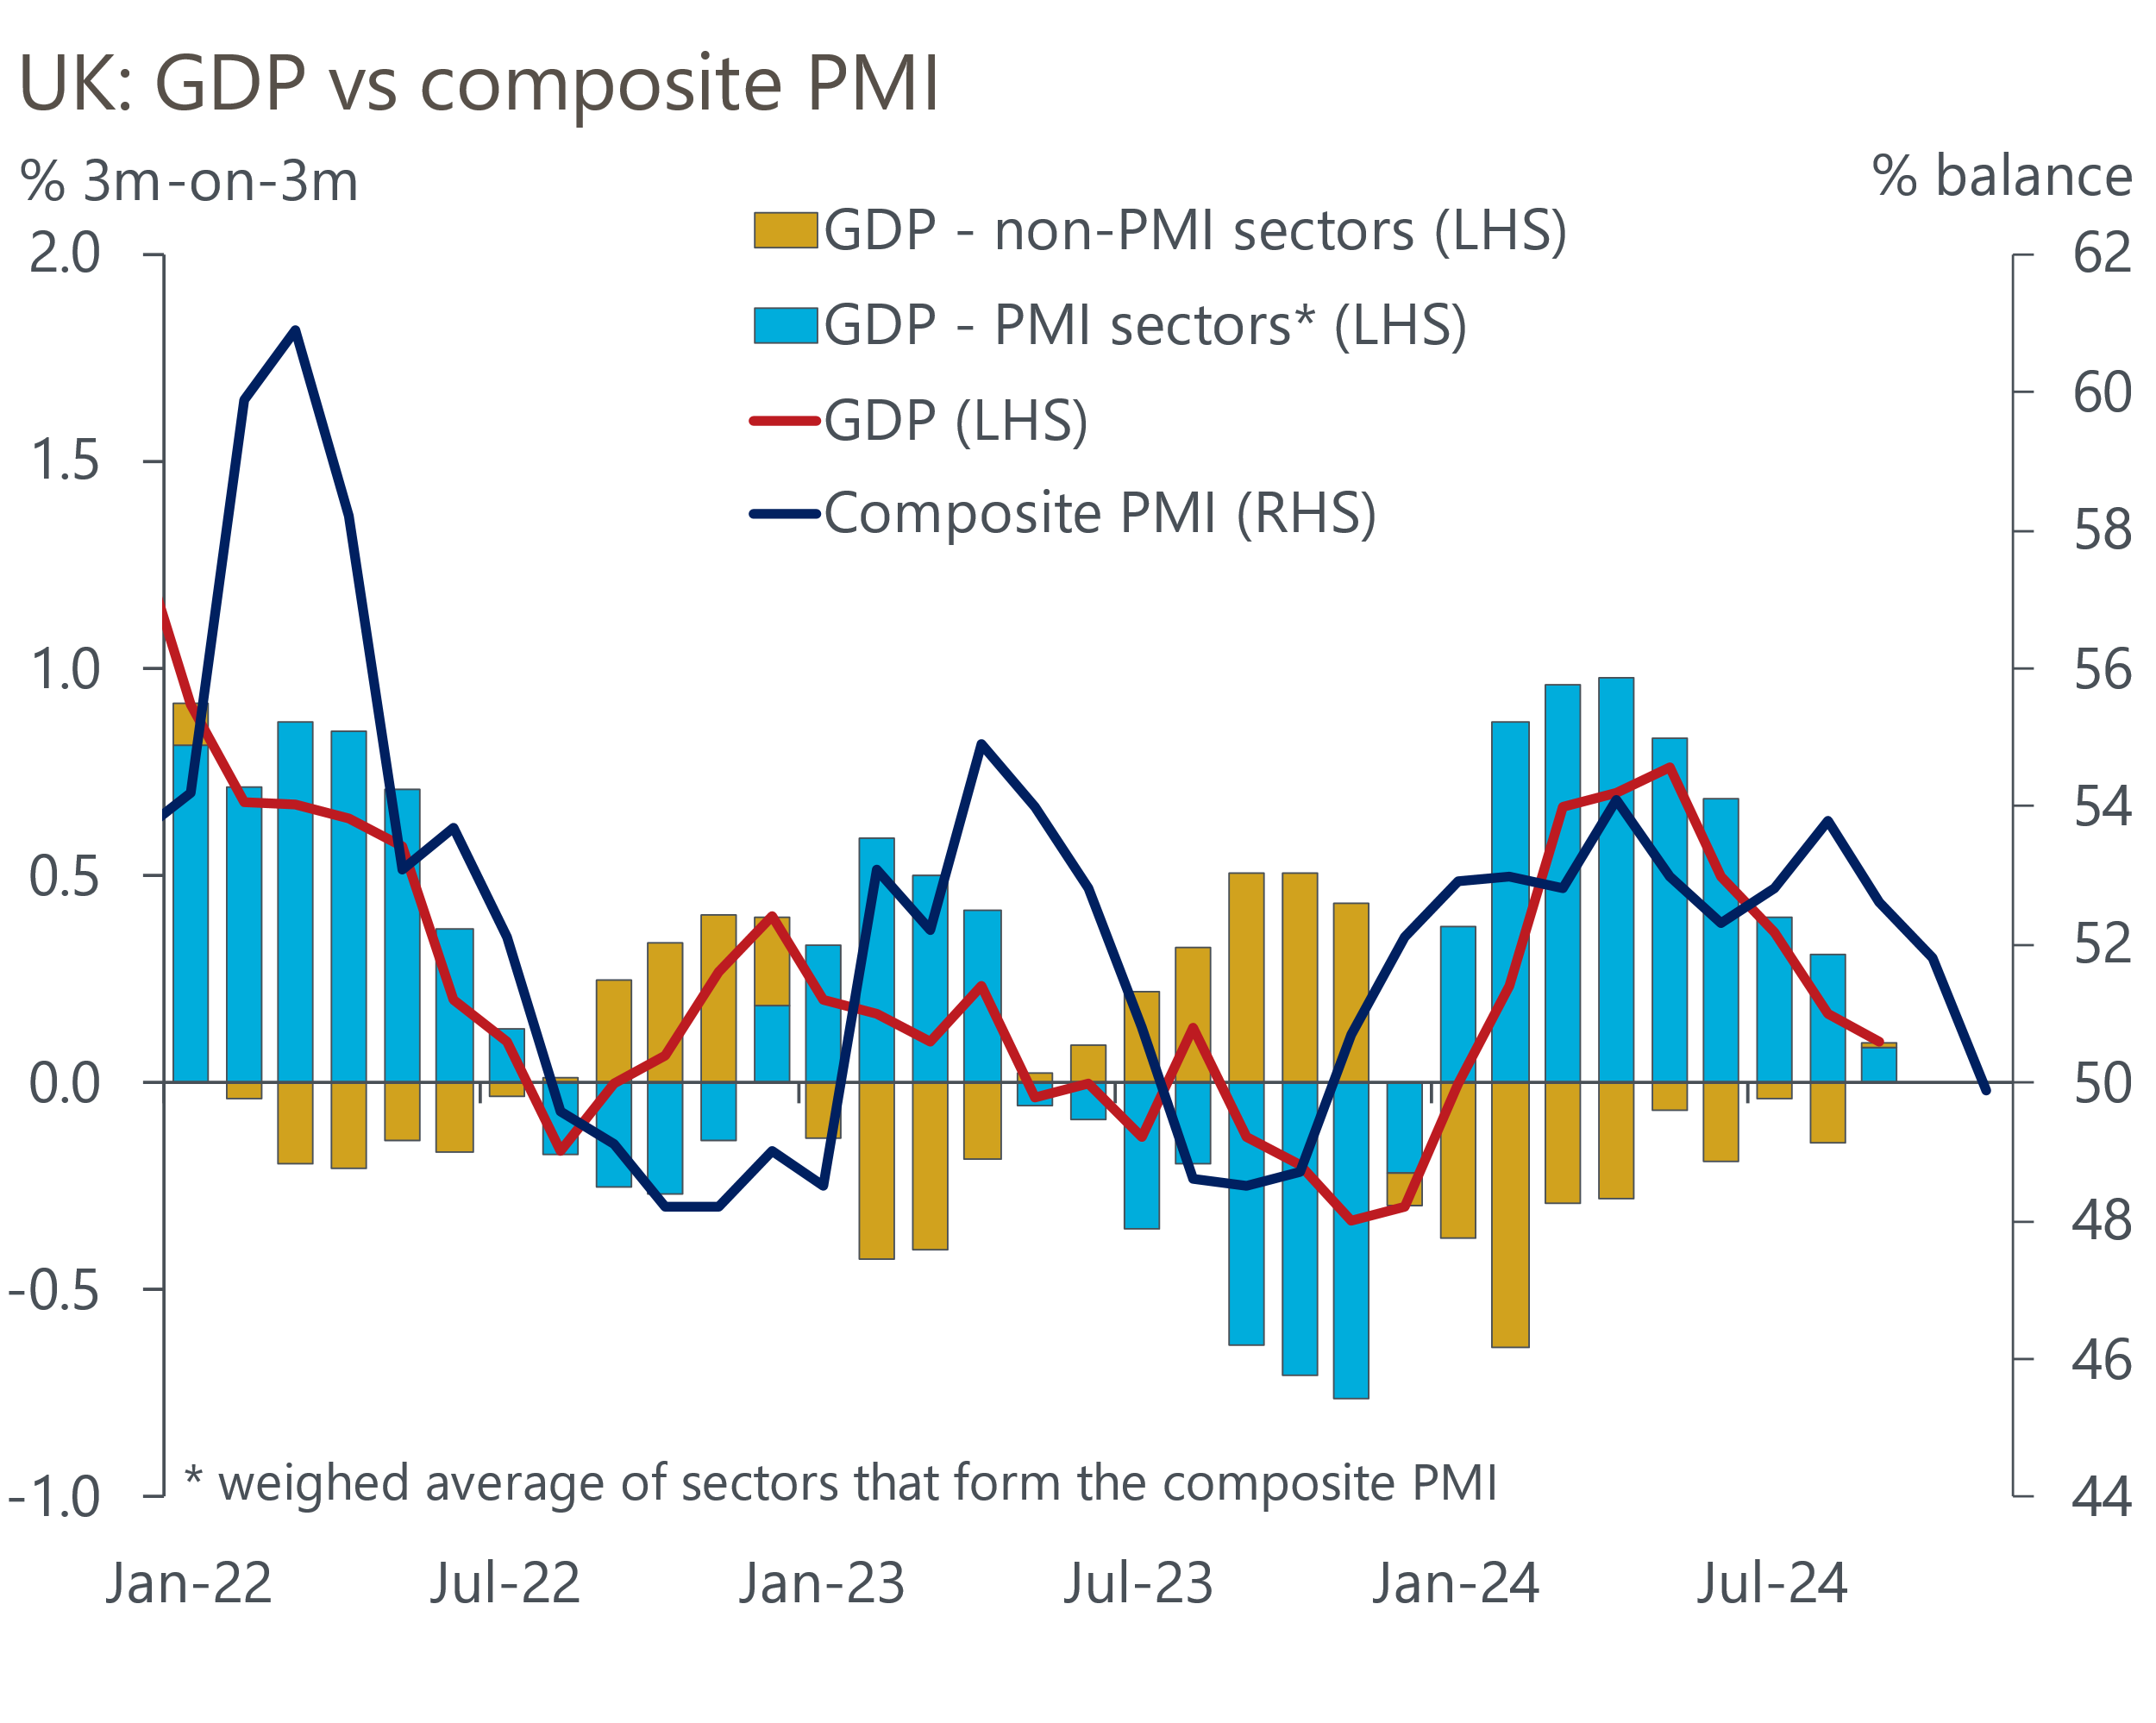
Sources: Oxford Economics, ONS, S&P Global

The week ahead
Next week's only major release is the Bank of England's Money & Credit data for October. We think a drop in mortgage rates during the summer and early-autumn is likely to have spurred a further increase in activity. Forward-thinking buyers will also have been keen to set purchases in train before the temporary stamp duty cut expires at the end of March. So we have pencilled in a rise in mortgage approvals to 66,600, from 65,600 in September. Moreover, we anticipate a modest rise in net mortgage lending to £2.8bn. Gross lending fell in September, and we expect some payback from this source to more than offset a modest uptick in repayments.
On the unsecured side, there were rises in both gross lending and repayments in September. Repayments were at a very high level, so we see scope for this to unwind in October. So while October’s weaker retail sales outturn suggests gross lending may have dropped back, we forecast that net unsecured lending rose to £1.7bn from £1.2bn in September.
Table 1: Week ahead calendar
Date | Events | Period | Measure | Unit | Previous | Forecast
Nov 29 | Nationwide house prices | Nov | m/m | % | 0.1 | 0.1
Nov 29 | Nationwide house prices | Nov | y/y | % | 2.4 | 2.3
Nov 29 | Mortgage approvals | Oct | Level | 000s | 65.6 | 66.6
Nov 29 | Mortgage lending | Oct | Net lending | £bn | 2.5 | 2.8
Nov 29 | Consumer credit | Oct | Net lending | £bn | 1.2 | 1.7
Source: Oxford Economics

Key forecasts
Table 2: UK forecast overview
(Annual percentage changes unless specified)
 | 2022 | 2023 | 2024 | 2025 | 2026 | 2027
GDP | 4.8 | 0.3 | 0.9 | 1.4 | 1.7 | 1.8
Private consumption | 7.3 | 0.5 | 0.8 | 1.7 | 1.5 | 1.6
Fixed investment | 5.1 | -0.1 | 1.0 | 0.8 | 3.4 | 2.5
Government consumption | 0.6 | 0.6 | 2.4 | 2.9 | 1.6 | 1.6
Exports of goods and services | 12.6 | -2.2 | -1.9 | 1.9 | 1.6 | 1.5
Imports of goods and services | 13.0 | -3.4 | 2.5 | 2.2 | 1.8 | 1.5
Industrial Production | -6.4 | -1.2 | -1.1 | 0.6 | 1.2 | 1.1
Consumer prices | 9.1 | 7.3 | 2.5 | 2.6 | 2.3 | 2.3
Unemployment rate (%) | 3.9 | 4.0 | 4.3 | 4.4 | 4.3 | 4.2
Current a/c balance (% of GDP) | -2.2 | -2.0 | -3.1 | -2.8 | -2.8 | -2.7
Government balance (% of GDP) | 4.1 | 4.9 | 4.5 | 3.6 | 2.9 | 2.1
Central bank policy rate (%, EOP) | 3.50 | 5.25 | 4.75 | 3.75 | 3.00 | 2.50
10yr govt. bond yield (%, EOP) | 3.67 | 3.54 | 4.50 | 4.25 | 3.85 | 3.42
Exchange rate (US$ per £, EOP) | 1.20 | 1.27 | 1.26 | 1.27 | 1.27 | 1.28
Exchange rate (euro per £, EOP) | 1.13 | 1.15 | 1.20 | 1.20 | 1.20 | 1.20
Source: Oxford Economics
Table 3: Quarterly forecasts for the UK
 | 2024 |  |  |  | 2025
 | Q1 | Q2 | Q3 | Q4 | Q1 | Q2 | Q3 | Q4
GDP (% year) | 0.3 | 0.7 | 1.0 | 1.7 | 1.4 | 1.3 | 1.5 | 1.5
CPI inflation (% year) | 3.5 | 2.1 | 2.1 | 2.4 | 2.6 | 2.5 | 2.8 | 2.6
Bank Rate (%, EOP) | 5.25 | 5.25 | 5.00 | 4.75 | 4.50 | 4.25 | 4.00 | 3.75
10yr gilt yield (%, EOP) | 3.95 | 4.17 | 4.00 | 4.50 | 4.41 | 4.38 | 4.32 | 4.25
US$ per £ (EOP) | 1.26 | 1.26 | 1.34 | 1.26 | 1.26 | 1.26 | 1.27 | 1.27
Euro per £ (EOP) | 1.17 | 1.18 | 1.20 | 1.20 | 1.20 | 1.20 | 1.20 | 1.20
Source: Oxford Economics

Latest Country Economic Forecast:
November 19, 2024

Recent publications

Data Insights
November's PMI won't set alarm bells ringing yet
Retail sales fell in October, but underlying picture remains decent
October public finances shows no progress on borrowing
Inflation rose in October due to a higher energy price cap
GDP growth underwhelmed in Q3

Research Briefings
Why the energy shock persisted for firms, but may soon fade
Macro impact of Trump’s tariffs shouldn’t be overstated
MPC sticks to the cut-hold tempo
Markets have soured on the Budget, but calm should return
MPC preview – November cut looks virtually certain

Contacts

Oxford Economics' UK team
- Andrew Goodwin - Chief UK Economist - agoodwin@oxfordeconomics.com
- Edward Allenby - UK Economist - eallenby@oxfordeconomics.com

